**Priors for classes**

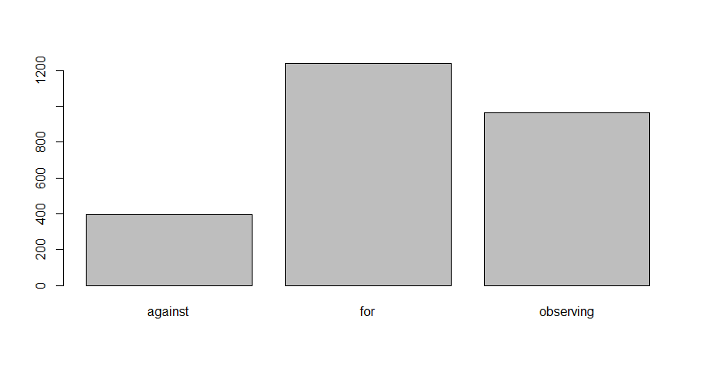

**Headline Frequency**

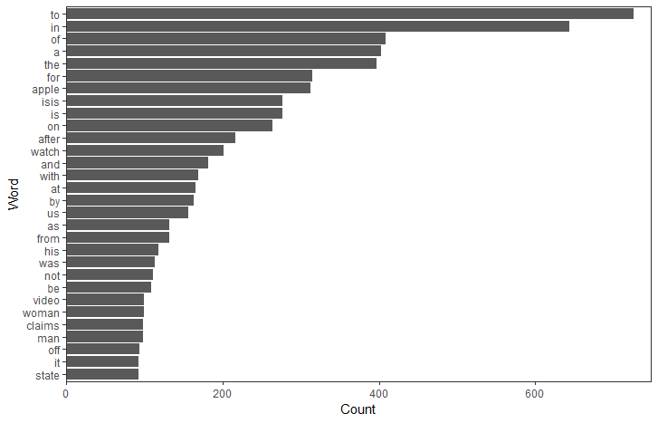

**Claim Frequency**

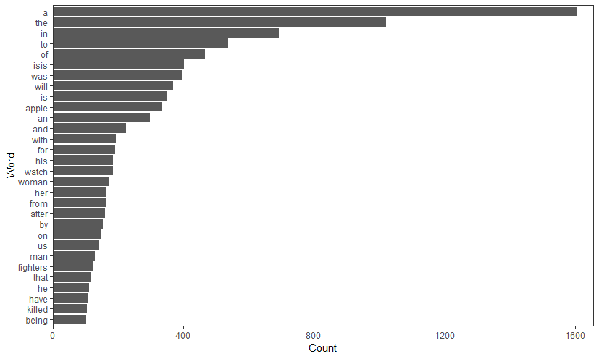

**Headline Wordcloud**

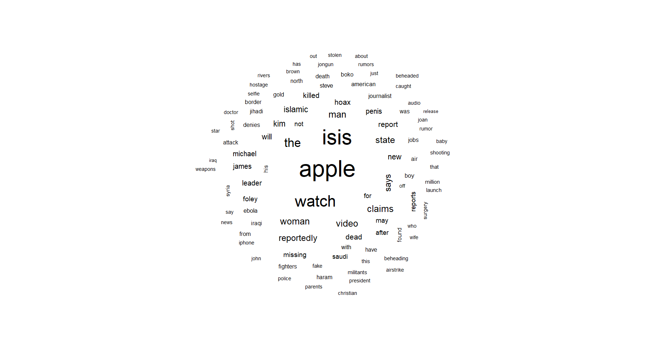

**Claim WordCloud**

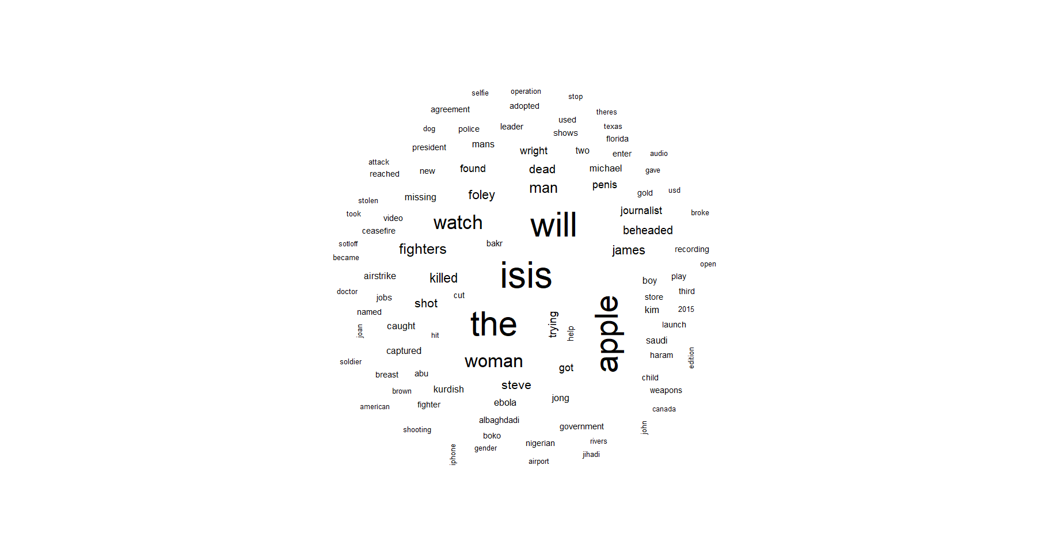

**Selective Stopword Cleaning**

stopwords("en")

[1] "i" "me" "my" "myself""we" "our" "ours""ourselves" "you"

[10] "your""yours" "yourself" "yourselves" "he" "him" "his" "himself" "she"

[19] "her" "hers""herself" "it" "its" "itself""they""them""their"

[28] "theirs""themselves" "what""which" "who" "whom""this""that""these"

[37] "those" "am" "is" "are" "was" "were""be" "been""being"

[46] "have""has" "had" "having""do" "does""did" "doing" "would"

[55] "should""could" "ought" "i'm" "you're""he's""she's" "it's""we're"

[64] "they're" "i've""you've""we've" "they've" "i'd" "you'd" "he'd""she'd"

[73] "we'd""they'd""i'll""you'll""he'll" "she'll""we'll" "they'll" "isn't"

[82] "aren't""wasn't""weren't" "hasn't""haven't" "hadn't""doesn't" "don't" "didn't"

[91] "won't" "wouldn't" "shan't""shouldn't" "can't" "cannot""couldn't" "mustn't" "let's"

[100] "that's""who's" "what's""here's""there's" "when's""where's" "why's" "how's"

[109] "a" "an" "the" "and" "but" "if" "or" "because" "as"

[118] "until" "while" "of" "at" "by" "for" "with""about" "against"

[127] "between" "into""through" "during""before""after" "above" "below" "to"

[136] "from""up" "down""in" "out" "on" "off" "over""under"

[145] "again" "further" "then""once""here""there" "when""where" "why"

[154] "how" "all" "any" "both""each""few" "more""most""other"

[163] "some""such""no" "nor" "not" "only""own" "same""so"

[172] "than""too" "very"

> length(stopwords("en"))

[1] 174

> neg_stops = c("isn't", "aren't","wasn't","weren't","hasn't","haven't","hadn't",

+ "doesn't","don't","didn't","won't","wouldn't","shan't","shouldn't",

+ "can't","cannot","couldn't","mustn't","no","nor","not")

> sup_neg_stops = c("against", "should", "could", "for")

>

> stops = setdiff(stopwords("en"), neg_stops)

> stops = setdiff(stops, sup_neg_stops)

> stops

[1] "i" "me" "my" "myself""we" "our" "ours""ourselves" "you"

[10] "your""yours" "yourself" "yourselves" "he" "him" "his" "himself" "she"

[19] "her" "hers""herself" "it" "its" "itself""they""them""their"

[28] "theirs""themselves" "what""which" "who" "whom""this""that""these"

[37] "those" "am" "is" "are" "was" "were""be" "been""being"

[46] "have""has" "had" "having""do" "does""did" "doing" "would"

[55] "ought" "i'm" "you're""he's""she's" "it's""we're" "they're" "i've"

[64] "you've""we've" "they've" "i'd" "you'd" "he'd""she'd" "we'd""they'd"

[73] "i'll""you'll""he'll" "she'll""we'll" "they'll" "let's" "that's""who's"

[82] "what's""here's""there's" "when's""where's" "why's" "how's" "a" "an"

[91] "the" "and" "but" "if" "or" "because" "as" "until" "while"

[100] "of" "at" "by" "with""about" "between" "into""through" "during"

[109] "before""after" "above" "below" "to" "from""up" "down""in"

[118] "out" "on" "off" "over""under" "again" "further" "then""once"

[127] "here""there" "when""where" "why" "how" "all" "any" "both"

[136] "each""few" "more""most""other" "some""such""only""own"

[145] "same""so" "than""too" "very"

> length(stops)

[1] 149

**Headline Frequency w/o irrelevant stopwords**

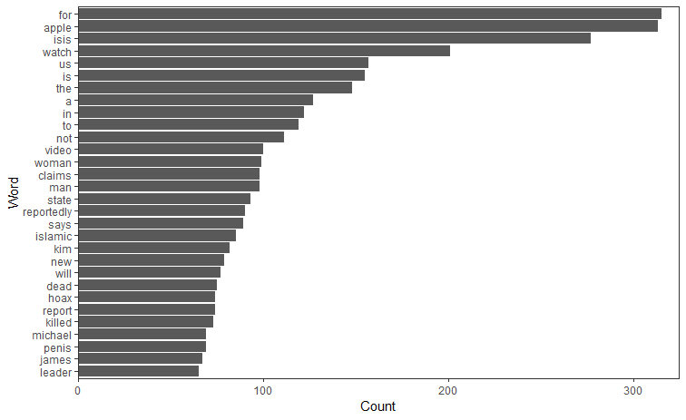

**Claim Frequency w/o irrelevant stopwords**

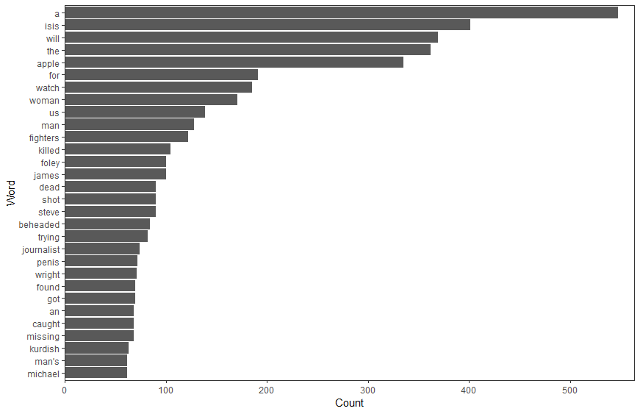

**Headline frequency by stance (for, against, observing)**

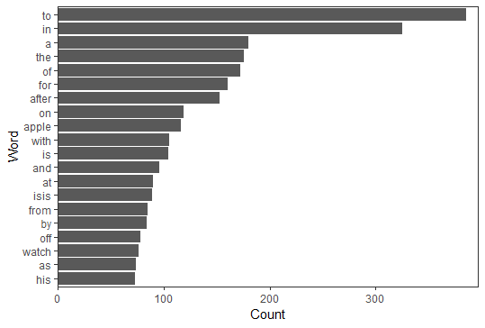 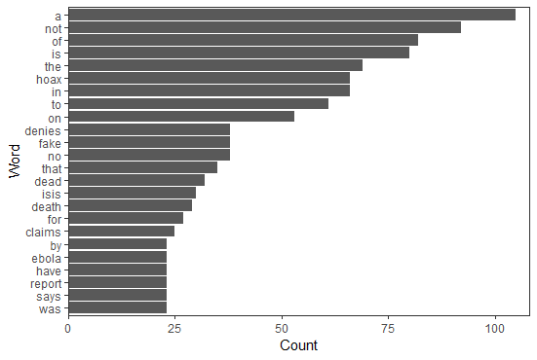 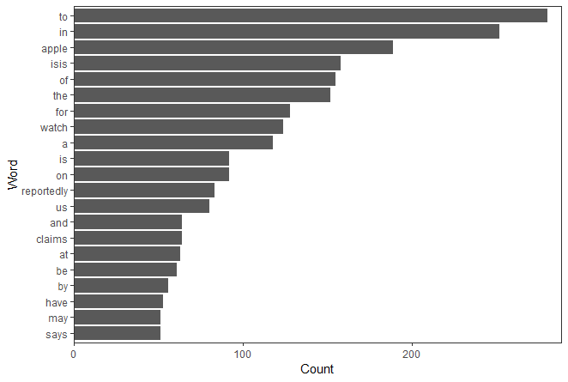

**Headline (w/o irrelevant stopwords) frequency by stance (for, against, observing)**

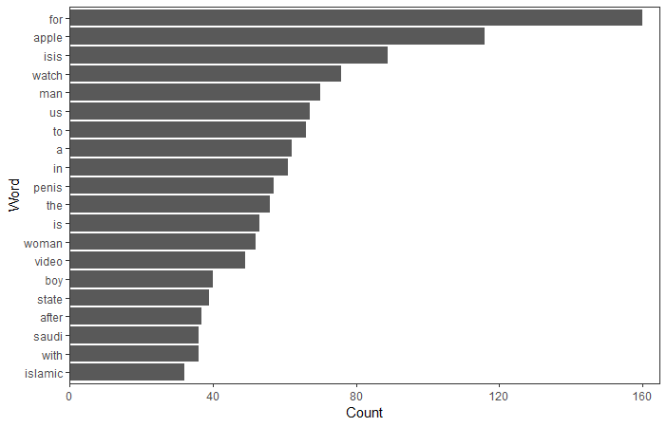 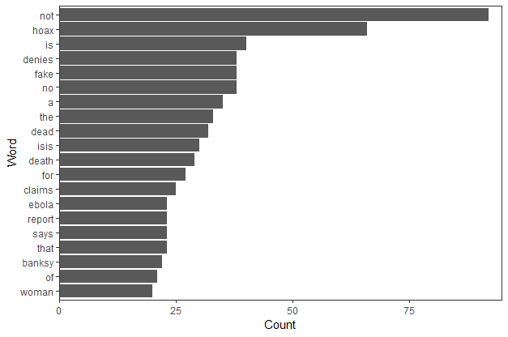 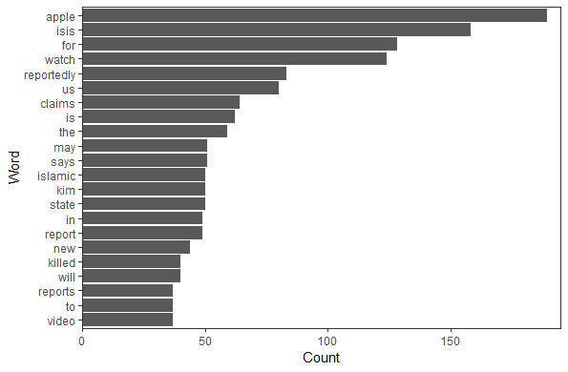

**Claim frequency by stance (for, against, observing)**

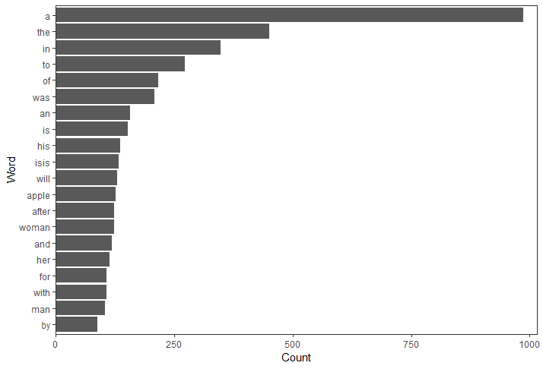 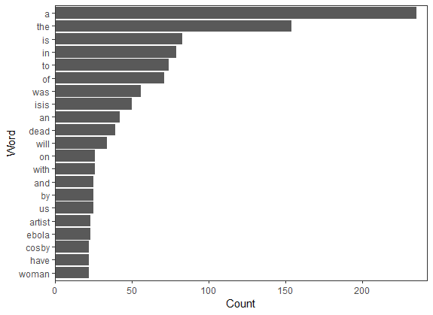 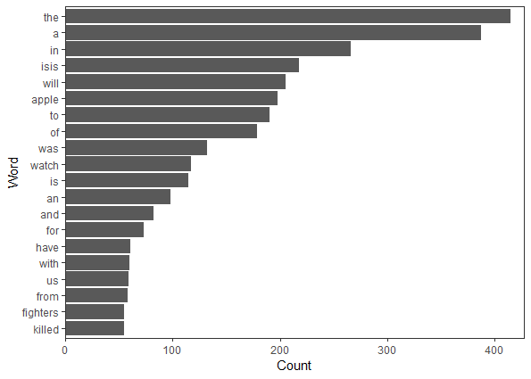

**Claim (w/o irrelevant stopwords) frequency by stance (for, against, observing)**

